Module 1 – Foundations Assessment
Topics: Linux CLI, Linux Permissions, Windows PowerShell, User & Service Administration, Networking, Virtualization, Git, and Blue Team Fundamentals
Total Points: 100
Suggested Time: 90–120 minutes

Part I – Multiple Choice
20 questions × 2 points = 40 points
1. Which Linux command displays the username of the currently logged-in user?
A. groups
B. whoami
C. passwd
D. iduser
2. What is the primary purpose of the Linux /etc/passwd file?
A. Store encrypted user passwords
B. Store information about user accounts
C. Store firewall rules
D. Store network interface configurations
3. What does the following command accomplish?
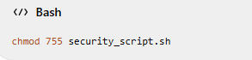
A. Makes the file readable only by root
B. Gives the owner read/write/execute permissions and others read/execute permissions
C. Removes all permissions from the file
D. Changes the owner of the file to root
4. Which command changes the owner of a file to root?
A. chmod root:root file
B. sudo userdel root file
C. sudo chown root:root file
D. sudo passwd root:root file
5. Why would a standard user normally receive a "Permission denied" message when attempting to read /etc/shadow?
A. The file does not exist
B. The file is protected because it contains sensitive authentication information
C. The network connection is unavailable
D. The file is stored on a Windows system
6. Which security principle is demonstrated by removing unnecessary administrator privileges?
A. Defense through obscurity
B. Least privilege
C. Network segmentation
D. Data redundancy
7. Which PowerShell command lists local user accounts?
A. Get-LocalUser
B. Get-UserAccount
C. Show-LocalUsers
D. List-Users
8. What is the purpose of the following PowerShell command?
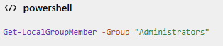
A. Lists all Windows services
B. Lists members of the local Administrators group
C. Creates a new administrator
D. Disables the Administrators group
9. Which command disables the Windows Guest account?
A. Remove-LocalUser -Name "Guest"
B. Stop-LocalUser -Name "Guest"
C. Disable-LocalUser -Name "Guest"
D. Block-LocalUser -Name "Guest"

10. What is the purpose of disabling an unnecessary service?
A. Increase the attack surface
B. Reduce unnecessary services and potential attack vectors
C. Increase the number of open ports
D. Remove the operating system
11. Windows Security Event ID 4625 represents:
A. Successful logon
B. Failed logon attempt
C. Successful system shutdown
D. Firewall configuration change
12. Which command is used in the Linux lab to inspect network interfaces?
A. ip address
B. network show
C. netconfig
D. show-interface
13. What does ping primarily test?
A. File permissions
B. Basic network reachability
C. User privileges
D. Git history
14. What is the purpose of DNS?
A. Assign file permissions
B. Translate domain names into IP addresses
C. Create Git repositories
D. Disable Windows services
15. What information can ss -tulpn help identify?
A. Local listening network ports and associated processes
B. Linux user passwords
C. Git commits
D. Windows user accounts

16. What is the primary characteristic of NAT networking in the lab?
A. The VM has no network connectivity
B. The VM shares the host's external network connection
C. The VM can communicate only with itself
D. The VM automatically becomes a public server
17. What is the primary purpose of a VMware snapshot?
A. Increase RAM
B. Create a recoverable point-in-time state
C. Change a user's password
D. Scan network ports
18. What does the following command do?
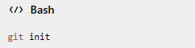
A. Deletes a Git repository
B. Creates/initializes a Git repository
C. Uploads code to GitHub automatically
D. Creates a Windows user
19. What does the following command do?
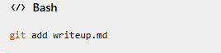
A. Deletes the file
B. Stages the file for a commit
C. Executes the file
D. Creates a new Linux user
20. Which concept describes reducing unnecessary exposed services and ports?
A. Attack Surface Reduction
B. Version Control
C. Data Normalization
D. Virtual Memory

Part II – Fill in the Blanks
10 questions × 2 points = 20 points
21.The Linux command used to display the current user's identity is:
____________________
22.The Linux command used to display the groups to which the current user belongs is:
____________________
23.The command used to change file permissions is:
____________________
24.The command used to change file ownership is:
____________________
25.The Windows PowerShell command used to list local users is:
____________________
26.The Windows PowerShell command used to stop a service is:
____________________
27.The networking command used to test whether another host is reachable is:
____________________
28.The protocol/service responsible for resolving domain names such as google.com to IP addresses is:
____________________

29.The Git command used to create a new repository is:
____________________

30.The Git command used to record staged changes in repository history is:
____________________

Part III – Command / Code Snippet Questions
10 questions × 2 points = 20 points
For each question, identify what the command does or provide the appropriate command.

31. What does this command accomplish?
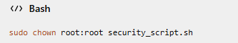
Answer:
32. What does this command accomplish?
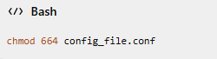
Answer:
33. Complete the command to inspect the current Linux IP configuration.
____________________________
34. Complete the command to test connectivity to the gateway:
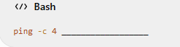
35. What information is being examined with this command?
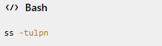
Answer:
36. Complete the PowerShell command to disable the Guest account:
____________________________

37. Complete the PowerShell command to disable the RemoteRegistry service:
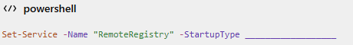
Answer:
38. What does the following command accomplish?
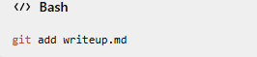
Answer:
39. Complete the Git command:
git commit -m "____________________________"
What is the purpose of the commit message?
Answer:
40. Examine the following output:
tcp LISTEN 0 128 0.0.0.0:22
What port is listening, and what common service is associated with that port?
Port: _________________
Service: __________________

Part IV – Descriptive / Short Answer
5 questions × 4 points = 20 points
41. Least Privilege
Explain the Principle of Least Privilege in your own words. Use one example from the Linux or Windows labs.
Answer:

42. Permission Management
A student attempts to execute:
cat /etc/shadow
and receives:
cat: /etc/shadow: Permission denied
Explain why this is an expected security behavior.
Answer:
43. Network Troubleshooting
A student reports that their VM cannot access an external website.
Using the techniques from Module 1, describe at least three things you would check.
Answer:

44. Virtualization Safety
Explain why you should create a baseline snapshot before performing a potentially destructive activity inside a cybersecurity lab VM.
Answer:
45. Git and Cybersecurity Documentation
Explain why Git is useful when documenting CTF findings or security lab activities.
Answer:

Part V – Scenario-Based Questions
Optional practical/advanced section
Scenario 1 – Linux Security Audit
You are given a Linux VM and asked to perform a basic security audit.
You discover:
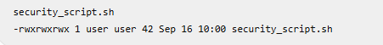
46. What security concern do you observe?

47. What command could you use to change the permissions?

48. What permission setting would you apply if the script should be executable by the owner and readable/executable by others?

49. How would you verify the change?

Scenario 2 – Windows Security Audit
You run:
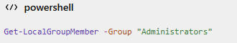
and receive:
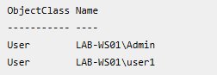
The security policy states that user1 should be a standard user.
50. What security issue has been identified?

51. What command could be used to remove user1 from the Administrators group?

52. What security principle does this remediation support?

Part VI – Practical Assessment
I would make this a separate hands-on assessment rather than putting the commands directly into the written test.
Practical Challenge – Module 1 Foundations
Scenario
You have been assigned a Linux cybersecurity lab VM. Your supervisor wants you to perform a basic security assessment using only techniques covered during Module 1.
You must:
Task 1 – Identity Audit
Determine:
- Current username
- Group membership
- User's home directory
- Default shell
Evidence required: Screenshot of your commands and results.

Task 2 – Permission Audit
Inspect the permissions of the assigned security file.
Determine:
- Current owner
- Current group
- Current permissions
Apply the required remediation.
Evidence required: Before-and-after screenshots.

Task 3 – Service Audit
Identify the status of the designated legacy service.
If it is active, apply the approved hardening procedure.
Verify the final state.
Evidence required: Screenshot showing verification.

Task 4 – Network Investigation
Determine:
- Linux IP address
- Interface name
- Default gateway
- DNS resolution
- At least one listening TCP port
Use the commands taught in Module 1.
Evidence required: Command/output screenshots.

Task 5 – Git Documentation
Create:
writeup.md
Your documentation must contain:
# Challenge Name

## Category

## Tools Used

## Observation

## Root Cause

## Remediation

## Verification

Initialize a Git repository and commit your documentation.
Evidence required:
git log --oneline

Final Student Reflection
53. What was the most challenging part of the Module 1 assessment, and why?

54. Which command or technique do you feel most confident using?

55. Which Module 1 topic do you need additional practice with?

56. Explain one way that Linux, Windows, networking, virtualization, and Git can work together during a cybersecurity investigation.

Suggested Grading Breakdown
Instructor reference
Section | Points
Part I – Multiple Choice | 40
Part II – Fill in the Blanks | 20
Part III – Command/Code Snippets | 20
Part IV – Descriptive Questions | 20
Written Assessment | 100

